

**TUNKU ABDUL RAHMAN UNIVERSITY COLLEGE**

**Faculty of Computing and Information Technology**

**Department of Mathematical and Data Science (DMDS)**

**BAMS 3043 Mathematical and Statistical Software**

**Assignment 1: Form Design**

**(Semester 1, Year 2021/2022)**

**PROG./ YEAR/ SEM/ TUTORIAL GROUP : RMM3 Y3S1 Group 2**

**LECTURER’S NAME : Ms. Tan Yan Bin**

|  |  |
| --- | --- |
| **STUDENT’S NAME** | **ID NO** |
| Lim Wei Yang | 20WMR09185 |

In Malaysia, everyone has Income Tax and Income Relief Items. So, I created the Excel Form for Calculation of Net Income. Before to use the form, you need to read this diagram to understand the guidelines.

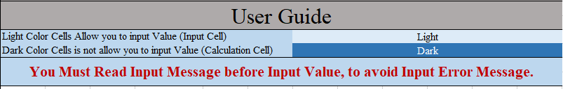

The diagram shows the user guide to use the form. The cells with light fill colour are user input cells which are allow user to input the value. On the other hand, the cells with dark fill colour are calculation cells which are not allow user to input the value.

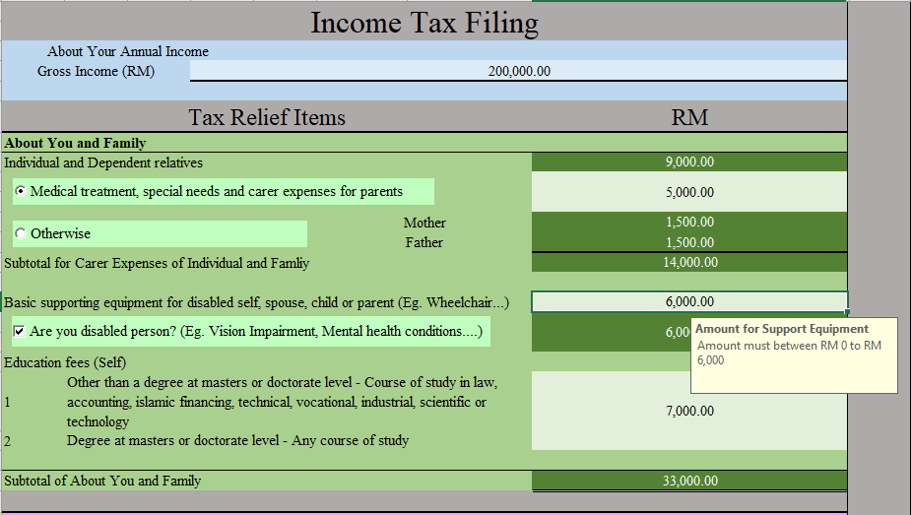

Income Relief Items consists of 9 classes which are Personal and Family Tax (Green), Medical Tax (Purple), Lifestyle Tax (Cyan), Child care Tax (Yellow), Deposit Tax (Orange), Couple Tax (Red), Children Tax (Pink), Insurance Tax (Blue) and Tourism Tax (Lime green). According to the user guide, user is allowed to input the value into light colour cells. No only the cells, there are some radio button and checkbox button which has light colour background which are enable to use. When you select the input cells there has the yellow message box which is order you to follow the data validation. If invalid Input have entered, the Error message box will appeared.

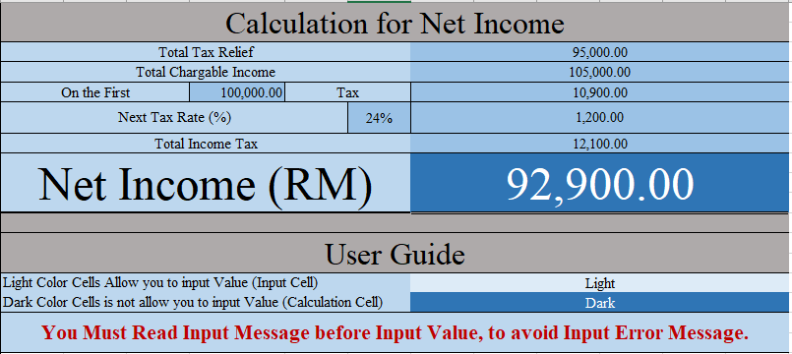

After entered all the input cells, the Total Chargeable Income has been calculated by subtracting the Total Tax Relief from Gross Income. According to the [Income Tax Rates](http://www.hasil.gov.my/bt_goindex.php?bt_kump=5&bt_skum=1&bt_posi=2&bt_unit=5000&bt_sequ=11), the income Tax on the first amount and tax rate has been calculated by using Vertical Look Up function (vlookup()) from the income tax rates table that created in hidden sheet. Finally, the net income is calculated by subtracting the income Tax on the first amount and income tax multiplied by tax rate from Total chargeable income.

This form is useful and user friendly because it is simple and faster to calculate the net income instead using the income online calculator. Also, this form brings the meaning for each input to let the user to understand the definition of the Tax Relief.

**Personal Thought**

From this Assignment, I have learned about the functions and Visual Basic Application in the Excel Software. Also, I can use this Excel to manage the data instead using MySQL and Oracle SQL because Excel Software is the Data Management Graphical User Interface Software which has only button to apply the data modification. Not only that, this excel software allow me to design the form like when you are designing a webpage. I did like to use it for the future when I go for work in public, and can use it to further explore the user interface and functions that I have not learned from this lecture session.